Scrum Wiki

Scrum FAQ

# Title: User Stories

## Question: What are User Stories in Scrum?

As a user, I want to see the availability of bikes for each station displayed on the map.

## Answer:

A user story is an informal, general explanation of a software feature written from the perspective of the end user. Its purpose is to articulate how a software feature will provide value to the customer.

## Useful Links :

* <https://www.atlassian.com/agile/project-management/user-stories>

# Title: Epics

## Question: What are Epics in Scrum?

As a customer, I want to find the best station with available bikes to start the journey.

## Answer:

An agile epic is a body of work that can be broken down into specific tasks (called user stories) based on the needs/requests of customers or end-users.

In other words, a series of related and interdependent stories makes up an epic, also known as a high-level user story.

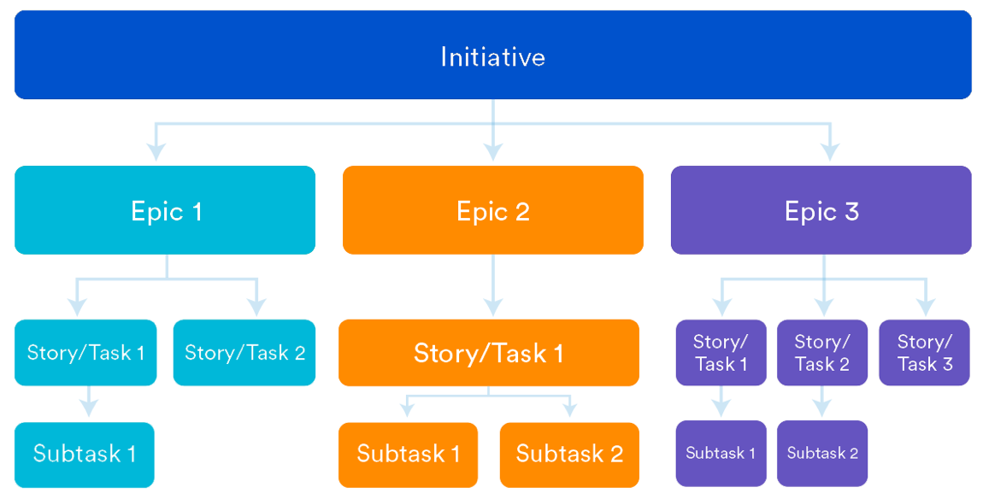

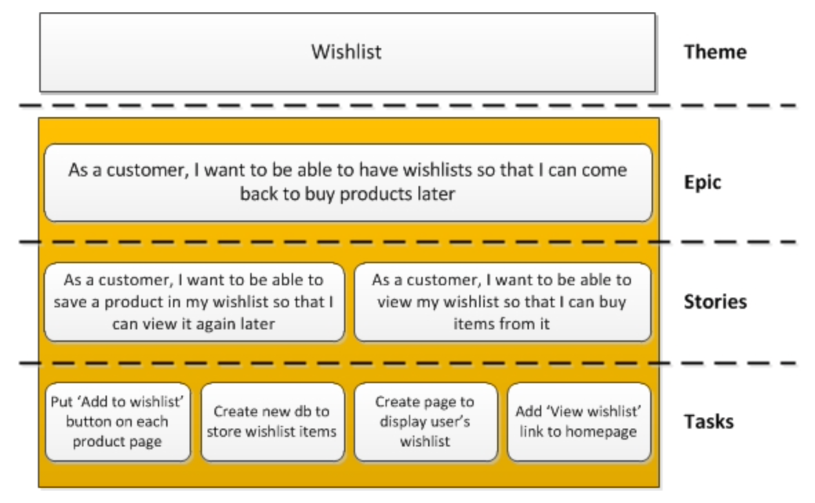

## Useful Links :

* <https://www.knowledgehut.com/blog/agile/what-is-an-epic-agile>
* <https://www.atlassian.com/agile/project-management/epics-stories-themes>
* <https://scrumandkanban.co.uk/theme-epic-story-task/>

# Title:

## Question:

Example….

## Answer:

Example….

## Useful Links :

# Title:

## Question:

Example….

## Answer:

Example….

## Useful Links :